Yajña – Sacrifice
By Vidvan Vijaya Manja
Inspired by Bhagavad Gita - Yogagurukula, January 2017
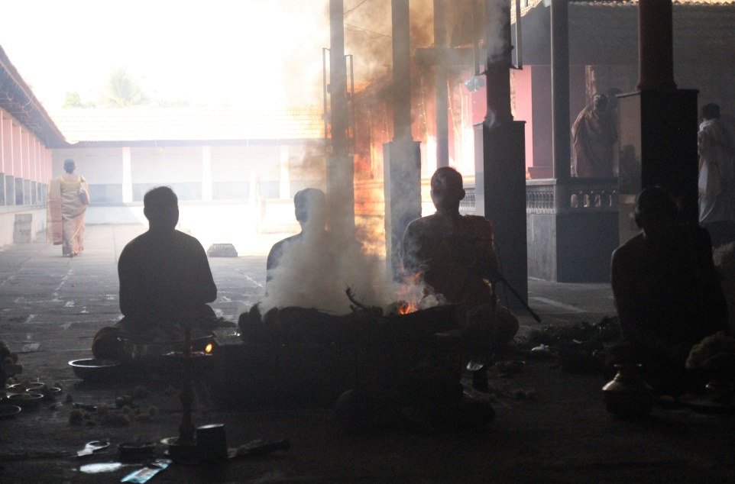
Many times we might wonder: ”Why should I worry about the external things too much, my life is my life only.” Some other people might think too much about the external world and not themselves at all. Neither one of these is a sacrifice, yajña. Krishna instructs us in Bhagavad Gita to perform all our actions without attachments and without any expectations, then only the action becomes a sacrifice.
Once there was a family and in their home they had chickens, sheeps and a cow. They were living happily and the owner was treating them nicely. One day a mouse entered into the house. It ate some food and sweets, but the other animals disliked it and the whole situation. Also the owner wanted to catch the mouse and purchased a mouse trap. The mouse was terrified, but the other animals were happy to see the mouse disappearing. The mouse asked for help, but it got refused and left alone. One morning the trap was closed and there was something inside. Everyone were waiting the mouse to be there, but it was a snake who bit the wife! She was hospitalized, the house was empty and the animals were necklected, but the mouse thrived on sweets. When the wife came back to the home it was decided that a stronger diet was necessary and more meat was needed. Two chickens were killed and eaten, then a cow was taken away. More relatives came and also a sheep had to be killed for their feast. The mouse was just laughing and continued eating the sweets.
Whatever you do has consequences and everything in this universe is connected. Don’t think why I have to do, you too are part of this universe and when you do actions which supports others it supports also you. If you eat only for your own benefit, for your enjoyment and to satisfy your taste, it is not yajña. When you eat to support your body-mind –system as a vehicle of a soul, so that spiritually you may uplift your self and help all the other beings in a best possible way, that is yajña. If you support the world wheel, the universe, you will support your self also. Acting and doing is always better than not doing. Then how weshould seethis from the liberation point of view, how is it possible to act without a will? If there are no gunas left (jivanmukta) how to act then? One doesn’t act for one self, one acts only for the support of others, for the maintenance of the world, lokasangraha.
There are three kinds of actions we do. Daily duties are called nitya karma, occasional duties are naimittika karma and the desired actions are kamya karma. Nitya karma can be performed as a yajña, any daily actions we do can be turned in to a sacrifice when not expecting anything from the action or from the result. All the actions has two different results, phala, there are seen results (drishta phala) and unseen results (adrishta phala). Adrishta phala is not a subject to our perception, it is the result from good or bad actions that we don’t experience directly right away. It goes to our karma account. When the time is ripe we will experience it one way or the other. When we have gunas, it is not possible to do nothing, even in our sleep we act, our body acts and lives even if we are not aware of it.
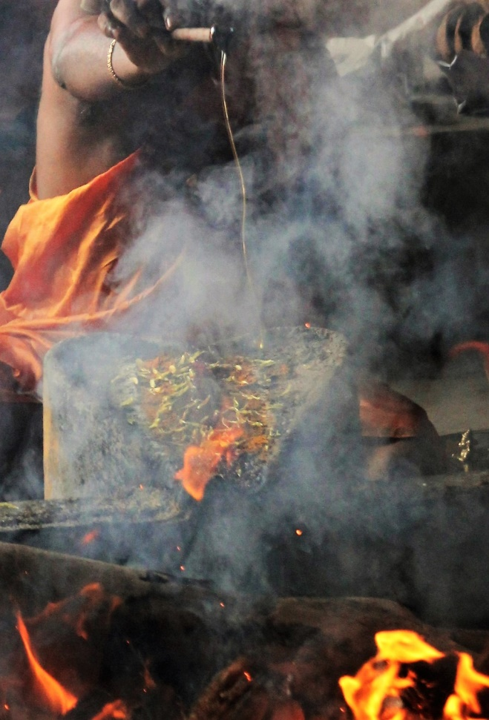
Then what action is, is it limited to our body or mind? The one who sits still but thinks a lot is acting, but the one who has controlled his senses and mind, who’s mind is still although externally acting, is in non-action. Action is related to our connection and attachment to objects, how we perceive them and how we react to them. It is related to not only our body but also to our speech, our mind, our intellect and our previous samskaras. Externally we can not make the difference between action and non-action. The one who is acting a lot externally (or also sitting still in deep meditation), who has a peaceful still mind, who rests in his own nature, is in non-action. Action is related to the state of mind, not the body. That’s why action is very important and necessary to reach the non-action , we need action to be aware of our attachments, we need action to be free from the action. Those who rests in their inner nature are the real yogis.
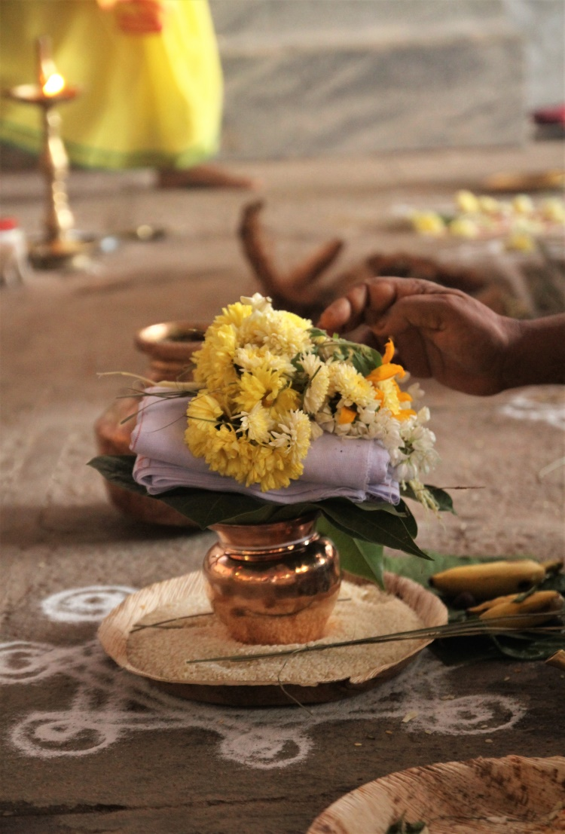
Yajña is also a name for a fire ceremony. In it different materials are thrown (sacrificed) into the fire with mantras for the purification purposes and for receiving the blessings from the gods. This fire ceremony concept symbolises the whole creation. It is for the upliftment of the individual and the society both. Together we go, together we learn and share everything, together we achieve the succes (saha na vavatu sahanau bhunaktu). It is not “me”, it is “we”. That “we” is the very essence of yajña. We is always stronger than me. In the end we all are alone, but only in the end the aloneness happen. To reach That “we” is needed. Nowadays the world is based on individualism, this “we” is disappearing and the very concept of yajña is disappearing with it. The whole creation rests in a yajna concept, this creation is for the beings to reach their ultimate nature. Connecting to the ignorance is painful for the Ultimate Self who rests in samadhi, but It connects and creates because of the duty and for the benefit of many. At the beginning of the creation the Creator advised beings to become many with a concept of yajña. Not to do actions which are not supporting the individual and society both. How? (BG3.11-)
Feel something greater than yourself, feel the gods and they will feel you. Try to feel each others. For both to get the ultimate success. To be able to do this, one has to surrender and melt, practice and detach. Practice helps to feel more and philosophy gives clarity and helps to purify the past karmas. The concept of this universe is difficult to understand, but in the fire ceremony we have this concept in a smaller frame and it can be more understandable. The materials used in a ceremony are sacrificed into the fire which goes upwards. That which goes up comes back to us in a form of rain, health and wealth. Ancient times the ceremonies lasted sometimes for many years and that had an impact to the whole environment and society. So how this yajña applies to us? Whatever you give comes back to you in a multiple way, but not always in a same form. It is a circle.
When ever I teach Gita I feel often unsatisfied of spoken words, I can’t tell or express well enough the meaning of this sacred text. The depthness of it goes beyond the words. The higher level of the yajña concept is not easy to understand, so the wise people came up with the God concept. (3.12-13) Do actions in a yajña way, share it and you shall be blessed by the God. But if you do not share what is given to you then you are a thief, what is given is not only yours, it belongs to everyone. In the end of the fire ceremony there is always food offered and after everyone has eaten then only the performers eat what has remained. This concept goes deeper than the ceremony or food. Whatever is yours, from that you give and whatever remains you should be grateful and satisfied for that.
There was a lady in Mysore. Sometimes we went to have a lunch in their home and after everyone had finished she took a plate and put some food on it. From that she took half away and gave that portion to the beggars waiting outside of their kitchen door. This happened daily. Her children were wondering and asking why their mother won’t eat more and just give the leftovers to the beggars. She said:” Then it is not my food, it is not from me. Then it is something that I don’t need and that is not a sacrifice.”
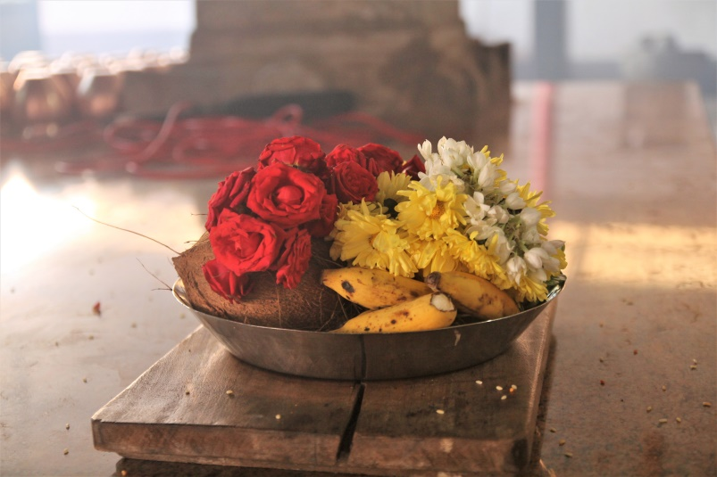
If we give from that what we truly need, then only it becomes a sacrifice, then only it is a yajña. The quality of that food or any object which is passed on like this is very high and sattvic. When you eat food that is prepared and given like yajña it effects a lot, it is a blessing. The yogis and priests should rest in satisfaction. In the end of the puja as the performers give a donation to the priest, if a priest is not satisfied with whatever he receives he stops to be a priest. The one who sacrifices his ego by doing selfless actions is supporting the world and benefit from that will come in a purifying form of burning the karma.
This yajña concept is the base of the creation and the very base of us human beings. It is the matter of the existence. Nowadays we are far away from the base, but the nature is in yajña at all times. The river flows and gives water to others. The tree will bear a fruit, for others. We are taking a lot from the nature, but we are not ready to give anything back. Greedness, desires and attachments rule the world now.This is not our true nature. We took birth with the yajña concept and by being aware of it and practicing it we have a chance to go towards to our real nature. Yyajña concept belongs to Purusa not to prakrti. By following that we can increase the sattvic qualities in us, through yajña we go towards the Self. Y ajña is not subject to knowledge it is subject to action. It doesn’t help that we know about sacrifice, it will increase our confusion, we actually have to act on it long time and let it transform us. When we allow the sacrifice to happen all our doubts will vanish. All our practices, philosophy and actions should end up in the yajña, otherwise it is a waste.
Action leads to knowledge and with the (self) knowledge Liberation happens. We need some knowledge to perform the action correctly, from action a birth of Knowledge arrises which is already the same as Moksha. What is the relationship of dharma and yajña? Dharma is a huge thing and yajña is a part of dharma. Performing one’s duty (dharma) can be done in a sacrificial way (yajna). When the individual dharma is performed as a universal way, for the benefit of others, it becomes more intense, as a yajña and so it has more sacrifice in it. Yajña depends on karma, but from where karma comes?
Karma comes from the individual self, when ego becomes alive, then also karma is born. This individual self “I” comes from Undestructable (akshara) and it also rests in Self. This is a big beautiful circle. Externally there is a fire in which many materials are sacrificed, but in a body level there is yajña possibility. I can sarifice food to the fire in my stomach. As Krishna says : “Aham vaishnavaro bhutva” “I am the digestive fire in every living being “. This sacrificing activity goes more and more subtle, from body to prana and to the mind. Different kinds of yajña such as material (the actual fire ritual), prana, tapas, svadhyaya and knowledge are there for the different kinds of practitioners. Highest one of these is the sacrifice into the knowledge, jnana yajña. This means sacrificing all the karma, all the actions, feelings and thoughts included, into the fire of knowledge. That Knowledge is the purest thing, that which burns all the precious things, everything. This knowledge is not easy to gain. Humility, service and surrender towads a guru is needed, as well as enquiring the right kind of questions. This will help a practitioner to become receivable and ready for the knowledge, BG4.33-34 Once that fire of Knowledge has burnt there is nothing left to burn. When Knowledge arrives after that there is nothing more to know.
When we let our senses rule us, we enjoy through them and think this pleasure is the only real thing, we become more far away from the yajña concept. It is a waste of our life, we are not here fulfilling our dharma and our body is of no use for this earth. When we think more broad, when we share what is “ours” we are living in the very concept of yajña. Our life becomes more precious when we support yajña. Some are sacrificing their time for more universal way, but the yogis are doing yajña in themselves, in a different way, which also supports everyone else and the whole society. This is something that all of us should think, do we want to be a waste or become useful? Do we want to enjoy limited pleasures or experience a permanent bliss, do we really want to fulfil our meaning to be born in this world with this body?
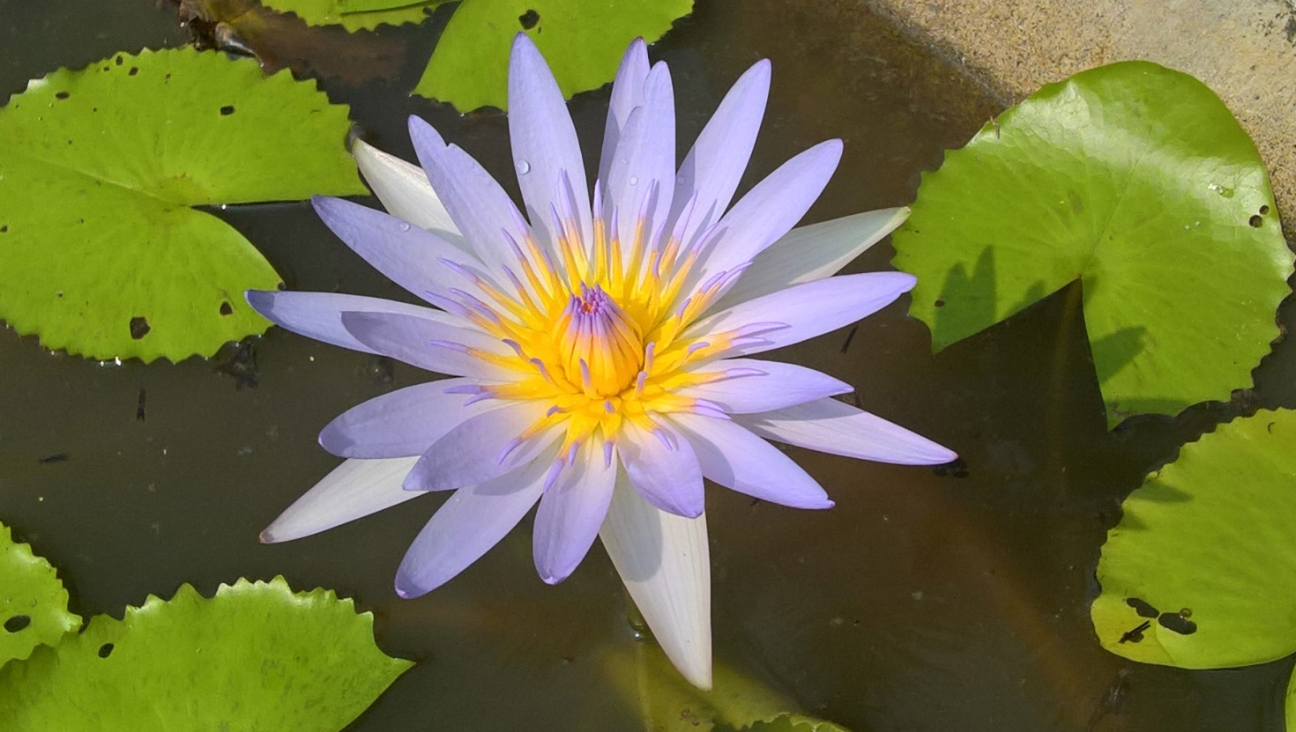
We can start practices in a small way. Small sacrifices becomes bigger within time. We can start the yajña within our daily actions like eating and trying to share more whether it is our possessions, our time or our knowledge. When we do actions in this way it is always supporting, individually and universally. The first limbs in ashtanga, yama and niyama, are the base of yajña, they are trying to make a practitioner a part of yajña concept by making him/her to live more truthfully and doing good for others. The very base of ashtanga is yajña. We pray in the end of our practice “lokah samastah sukhino bhavantu and kale varsatu parjanyah..” We wish well for others and by doing that we also transform ourselves, our own nature becomes selfless and giving.
As much as I pray for others that much I also pray for myself. I am always included in the “other”. The more subtle yajna goes it becomes harder, more sacrifices has to be made, but at the same time it becomes more meaningful. When this sacrifical nature takes more space within us it also makes us more complete.
Om Shantih

